# Complete scope and implementation plan — gated Integration Spec workflow
This plan covers the **full target system**: two-phase Research/Writer (mostly done), deterministic validators (done), **gated orchestration** (not done), optional Cursor Task usage, and documentation/CI. It is the blueprint to implement end-to-end operations in your repos.
---

## 1. Vision

Business Analysts produce MES→CMdS Integration Specifications through a **gated pipeline**:

1. Minimum inputs collected up front
2. **Research** (Cursor) → structured `research/*.yaml`
3. Machine validation + **human approval**
4. **Writer** (new Cursor chat) → `spec/*.md` from research only
5. Drift validation + Word export

**Orchestration** is primarily a **script + runbook** (and optionally a Cursor Skill), not one supervisor agent calling Research/Writer sub-agents. **Cursor Task** is optional inside Turn 1 for read-only exploration only.

---

## 2. Current state vs target

| Capability | Status | Location |
|------------|--------|----------|
| Research / Writer prompts | Done | `medicare-validation-rules/prompts/` |
| Phase + always-on rules | Done | `.cursor/rules/*.mdc` |
| Research JSON Schema | Done | `schemas/integration-research.schema.json` |
| `validate_research.py` | Done | `tools/validate_research.py` |
| `validate_spec_against_research.py` | Done | `tools/validate_spec_against_research.py` |
| `md_to_docx.py` | Done | `tools/md_to_docx.py` |
| Member Eligibility README (two-turn) | Done | `mes-cmds-member-eligibility/README.md` |
| Architecture doc + diagrams | Done | `docs/Integration_Spec_Creation_Architecture.*` |
| **Orchestrator script (gates + prompts)** | **Not done** | Planned: integration `scripts/` |
| **Workflow Cursor Skill** | **Not done** | Optional: library or integration `.cursor/skills/` |
| **CMS / Medicaid.gov snapshots** | **Not done** | Optional: `references/` |
| **CI workflow** | **Not done** | Optional: GitHub Actions |
| **SDK headless runs** | **Not done** | Future |

---

## 3. Complete scope

### 3.1 In scope

**A. Process & gates**

- Stage 0: Workspace + dependency checks
- Stage 1: Research minimum inputs (flow, source, target, rules, VVL paths)
- Stage 1b: `validate_research.py` (blocking)
- Stage 2: Human approval of research YAML (explicit Y/n + optional reviewer id/date)
- Stage 3: Writer minimum input (research YAML path only; remind **new chat**)
- Stage 3b: `validate_spec_against_research.py` (blocking)
- Stage 4: `md_to_docx.py` (blocking unless Pandoc missing with clear message)
- Audit log line per stage (timestamp, stage, pass/fail) optional but recommended

**B. Orchestrator (primary deliverable)**

- PowerShell script (Windows-first; aligns with `export-spec-docx.ps1`)
- Resolves `medicare-validation-rules` relative to integration root
- Copies Turn 1 / Turn 2 prompts to clipboard or prints them clearly
- Waits for file existence (`research/*.yaml`, `spec/*.md`)
- Invokes validators with correct exit-code handling
- Config file or parameters: flow name, file names, library path

**C. Cursor integration (documentation + prompts)**

- Document when to use **Task** (`explore`, `readonly`) in Turn 1 only
- Enforce “new chat for Writer” in script + README + architecture doc
- Optional **Workflow Skill** mirroring script gates in chat

**D. Library / integration docs**

- `docs/Orchestration_Flow.md` (Start→End diagram + gate table)
- Update integration README with “run orchestrator” as primary entry
- MANIFEST entry for orchestrator path (optional)

**E. Testing**

- Fixture-based tests for validators (exists)
- Orchestrator smoke test: dry-run with `tests/fixtures` paths (new)

### 3.2 Out of scope (v1)

| Item | Reason |
|------|--------|
| Single parent agent orchestrating Research + Writer via Task | Weak Writer isolation |
| Agent writing into `medicare-validation-rules` | SME governance |
| Live Medicaid.gov fetch in Research | Needs snapshot ingest pipeline |
| Full Markdown AST spec linter | High effort; validators are subset parity only |
| Automatic PR creation / CMdS deployment | Different product |
| Replacing human review with auto-approve on validator pass | Process decision |
| Cursor Automations for full E2E without human gates | v2 optional |

### 3.3 Future scope (v2+)

- Python orchestrator (cross-platform)
- `references/` + `fetch_cms_snapshot.py` + MANIFEST `web_sources`
- GitHub Actions: validate research/spec on PR
- Cursor SDK pipeline for scheduled re-research
- Stronger `validate_spec` (orphan GAPs in spec, target_attribute parity)
- Approval recorded in `research/meta.approval` block (schema extension)

---

## 4. Target architecture

```mermaid
flowchart TD
Start([Start])

Orch[Orchestrator script or Workflow Skill]
Orch --> S0[Stage 0 checks deps workspace files]

S0 --> S1[Stage 1 emit Research prompt open Chat 1]
S1 --> AgentR[Cursor Research Agent]
AgentR --> TaskOpt[Optional Task explore readonly]
TaskOpt --> YamlOut[research Integration_Research yaml]

YamlOut --> S1b[Stage 1b validate_research.py]
S1b --> S2[Stage 2 human approve YAML]

S2 --> S3[Stage 3 emit Writer prompt new Chat 2]
S3 --> AgentW[Cursor Writer Agent research only]
AgentW --> SpecOut[spec Integration_Spec md]

SpecOut --> S3b[Stage 3b validate_spec_against_research.py]
S3b --> S4[Stage 4 md_to_docx.py]
S4 --> End([End])
```
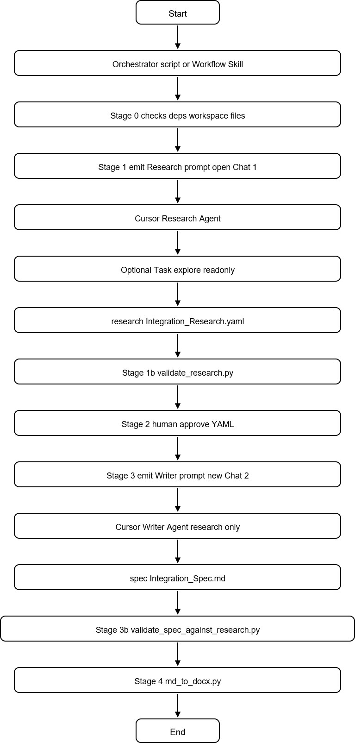

**Actors**

| Actor | Responsibility |
|-------|----------------|
| BA | Runs orchestrator, pastes prompts, opens chats, approves YAML |
| Orchestrator | Files, validators, prompts, gates |
| Research agent | Chat 1 + optional Task |
| Writer agent | Chat 2, no raw artifacts |
| MMIS SME | Library updates (xlsx, VVL), not orchestrator |

---

## 5. Implementation plan (phased)

### Phase 0 — Baseline verification (0.5 day)

**Goal:** Confirm two-phase assets work on Member Eligibility before orchestration.

| Task | Acceptance criteria |
|------|---------------------|
| Multi-root workspace opens library + integration | `@prompts`, `@rules` resolve |
| `pip install -r ../../medicare-validation-rules/requirements.txt` | Success |
| Run validators on fixtures | `valid_research.yaml` passes; `invalid_research.yaml` fails |
| Manual Turn 1 + Turn 2 once (or dry-run with fixtures for spec validator) | Document blockers |

**Deliverable:** Short “baseline” note in `docs/Orchestration_Flow.md` § Prerequisites.

---

### Phase 1 — Orchestrator script (2–3 days) — **core**

**Goal:** One command drives gates and prompt emission.

| # | Task | Details |
|---|------|---------|
| 1.1 | Create `scripts/run-integration-spec-workflow.ps1` | Param: `-FlowName`, `-ResearchFile`, `-SpecFile`, `-RulesRoot` |
| 1.2 | Stage 0 | Check `source/MEMBERELIGIBILITY.csv`, `target/MemberEligibilityVO.md`, library folder, `python`, validators exist |
| 1.3 | Stage 1 | Print/copy Research prompt with resolved `@` paths; pause until Enter when YAML exists |
| 1.4 | Stage 1b | Run `validate_research.py`; loop or exit on fail |
| 1.5 | Stage 2 | `Read-Host "Approve research for Writer? (Y/n)"`; exit on `n` |
| 1.6 | Stage 3 | Warn “NEW Cursor chat”; print Writer prompt with **only** research `@` |
| 1.7 | Stage 3b–4 | Wait for spec md; `validate_spec_against_research.py`; `md_to_docx.py` |
| 1.8 | Logging | Optional `-LogFile` with stage timestamps |
| 1.9 | Config | `scripts/workflow.config.json` defaults for Member Eligibility |

**Acceptance criteria**

- Script exits non-zero on validator failure or user decline
- Script never modifies `medicare-validation-rules/rules/`
- README “How to regenerate” points to script as primary path

**Files**

- `integrations/mes-cmds-member-eligibility/scripts/run-integration-spec-workflow.ps1`
- `integrations/mes-cmds-member-eligibility/scripts/workflow.config.json` (optional)

---

### Phase 2 — Documentation and diagrams (1 day)

| # | Task |
|---|------|
| 2.1 | Add `docs/Orchestration_Flow.md` (Start/End diagram, stage table, Task usage) |
| 2.2 | Link from `README.md` and `Integration_Spec_Creation_Architecture.md` |
| 2.3 | Regenerate architecture Word if needed |
| 2.4 | Update `MANIFEST.yaml` `conventions.orchestrator` path (library) |

---

### Phase 3 — Workflow Cursor Skill (1–2 days) — optional

**Goal:** In-Cursor checklist when script is not used.

| # | Task |
|---|------|
| 3.1 | `.cursor/skills/integration-spec-workflow/SKILL.md` in library or integration |
| 3.2 | Skill steps mirror Phase 1 stages; use `AskQuestion` for approvals |
| 3.3 | `disable-model-invocation` or explicit “run skill” only — avoid always-on |
| 3.4 | Skill references `@prompts` and `@.cursor/rules` per stage |

**Acceptance:** BA can type “Run integration spec workflow” and get gated steps without PowerShell.

---

### Phase 4 — Validator and schema hardening (1–2 days) — optional

| # | Task | Value |
|---|------|-------|
| 4.1 | `validate_spec`: flag GAP ids in spec not in research | Closes orphan gap hole |
| 4.2 | `validate_spec`: check `target_attribute` appears in §3 | Stronger parity |
| 4.3 | Schema: optional `meta.approval` (approved_by, date) | Records HITL in YAML |
| 4.4 | `validate_research`: resolve library paths for `meta.sources` | CMS snapshots in library |

---

### Phase 5 — CI and governance (1–2 days) — optional

| # | Task |
|---|------|
| 5.1 | GitHub Action: on PR touching `research/*.yaml` → `validate_research.py` |
| 5.2 | On PR touching `spec/*.md` → both validators |
| 5.3 | CODEOWNERS: `rules/` → MMIS SME |

---

### Phase 6 — First production run (ongoing)

| # | Task |
|---|------|
| 6.1 | Run orchestrator end-to-end for Member Eligibility (113 fields) |
| 6.2 | BA/SME sign-off on research YAML |
| 6.3 | Writer pass + spec validator + docx |
| 6.4 | Capture lessons: false positives, prompt tweaks |

---

## 6. Stage specification (orchestrator contract)

| Stage | ID | Minimum inputs | Automated action | Human gate | Output |
|-------|-----|----------------|------------------|------------|--------|
| Setup | 0 | Workspace paths | File/deps check | — | Continue / stop |
| Research prompt | 1 | Source, target, rules, VVL | Emit prompt | User runs Chat 1 | `research/*.yaml` |
| Validate research | 1b | YAML path | `validate_research.py` | — | Pass/fail |
| HITL | 2 | Approved YAML | — | **Y/n** | Proceed / stop |
| Writer prompt | 3 | Research path only | Emit prompt + new chat reminder | User runs Chat 2 | `spec/*.md` |
| Validate spec | 3b | research + spec paths | `validate_spec_against_research.py` | — | Pass/fail |
| Export | 4 | spec md | `md_to_docx.py` | — | `.docx` |
| Done | End | — | Summary | — | Deliverables list |

**Cursor Task (optional, inside Stage 1 / Chat 1 only)**

- Trigger: Research agent or Skill suggests readonly `Task` when field count > N or first run
- Not used in Stages 1b, 2, 3, 3b, 4

---

## 7. Roles and RACI (summary)

| Activity | BA | Orchestrator | Research agent | Writer agent | MMIS SME |
|----------|----|--------------|----------------|--------------|----------|
| Provide source/target | A | I | I | — | C |
| Run Research chat | R | I | R | — | — |
| Validate research YAML | R | A | — | — | C |
| Approve research | A | I | — | — | C |
| Run Writer chat | R | I | — | R | — |
| Validate spec / docx | R | A | — | — | — |
| Update T-MSIS library | I | — | — | — | A |

---

## 8. Risks and mitigations

| Risk | Mitigation |
|------|------------|
| BA skips orchestrator | README + training; CI on PR |
| Writer in same chat as Research | Script + Skill stress new chat |
| Validator false positives on §3/§4 | Tune regex; document heading conventions in Writer prompt |
| Pandoc missing | Stage 4 clear error; `export-spec-docx.ps1` fallback |
| Research agent edits library | Rules + no write paths in orchestrator |
| Task subagent invents mappings | Parent must write YAML from citations; validate_research catches VVL/DE |

---

## 9. Effort summary

| Phase | Effort | Priority |
|-------|--------|----------|
| 0 Baseline | 0.5 d | P0 |
| 1 Orchestrator script | 2–3 d | **P0** |
| 2 Docs | 1 d | P0 |
| 3 Workflow Skill | 1–2 d | P1 |
| 4 Validator hardening | 1–2 d | P1 |
| 5 CI | 1–2 d | P2 |
| 6 Production run | 2–5 d (calendar) | P0 |

**Minimum viable orchestration:** Phase 0 + 1 + 2 + 6 (~4–5 dev days + BA time for full 113-field research).

---

## 10. Definition of done (program level)

- [ ] BA can run **one script** from integration project through Start→End gates
- [ ] Research YAML validated before approval prompt
- [ ] Writer prompt issued only after explicit approval
- [ ] Spec validated against research before Word export
- [ ] Documentation includes orchestration diagram and Task placement
- [ ] Member Eligibility deliverables: `research/*.yaml`, `spec/*.md`, `spec/*.docx` traceable to `MANIFEST` dictionary version

---

## 11. Recommended next action

Implement **Phase 1** (`run-integration-spec-workflow.ps1`) and **Phase 2** (`docs/Orchestration_Flow.md`) first; defer Skill and CI until the script is used once on Member Eligibility.

If you want this executed in the repo, say **PowerShell** vs **Python** for the orchestrator and whether to include **Phase 3 Skill** in the same delivery.

